How to Reset the TCP/IP Stack in Windows XP:
Unlike Windows 9x, you cannot reinstall TCP/IP in Windows XP. You can, however, reset the TCP/IP protocol stack to its original condition. This is Windows XP equivalent to reinstalling TCP/IP.
To reset the TCP/IP protocol stack, do the following:
Click Start and select Run from the menu.
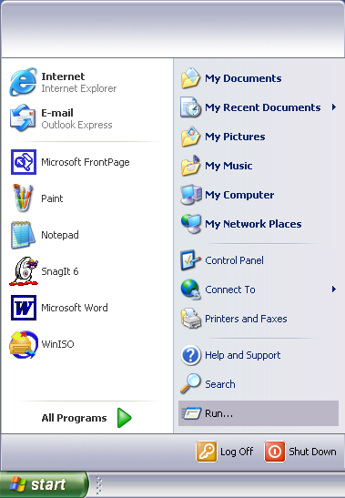

The Run dialogue box appears.
In the Open field, enter the following command: netsh int ip reset resetlog.txt.
Click OK.
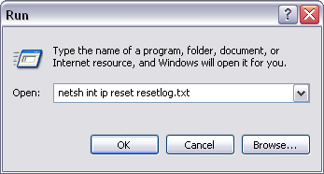

A window similar to the following will appear for a few seconds and then disappear.
You're done.
